
Lesson 15 Teacher's Key: Ready to Show
TIC-80 - Instructor Reference Only
VIDEO GAME CREATION

How This Key Is Different Today
There's no new Level 1 solution to give this week - Lesson 15 is a polish-and-present day, not a new-mechanic day. This Key instead consolidates the most common last-mile issues seen across this engine's Lessons 2-14, to help you diagnose a stuck student quickly during polish time.
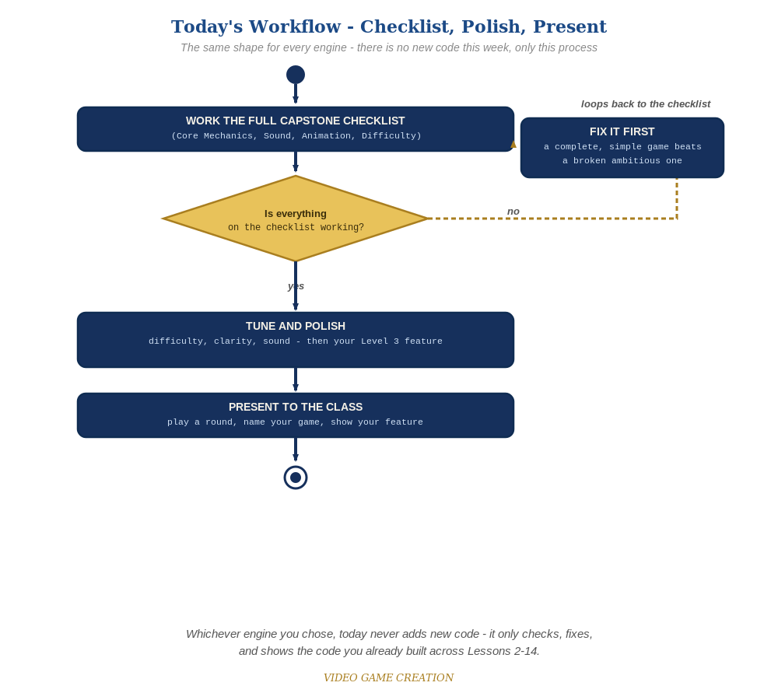
Today never adds new code - the same checklist-polish-present loop applies no matter which engine you chose.

Known Recurring Quirks in This Engine
- Iterating a table forward while removing entries from it (should count backward: for i=#t,1,-1), which skips entries or errors depending on what's being removed.
- A leftover debug print() statement cluttering the screen, easy to miss since TIC-80 has no separate console/output panel.
- SFX Editor slot numbers that drifted out of sync with what's referenced in code, especially after adding Lesson 12/14's new sounds.

Fast Diagnostic Questions
- "Are you counting UP or DOWN through this table, and are you removing entries from it?" - the single most common structural bug by this point in TIC-80.
- "What's actually printed on screen right now that shouldn't be?" - a fast way to spot leftover debug output.

If a Student Is Significantly Behind
Prioritize getting Lessons 6-11's Level 1 (win/lose, restart, multiple waves) solidly working before anything from Lessons 12-14 - a complete, simple game presents better than a broken ambitious one.

Presentation Day Notes
- Have students type run and confirm a clean start before presenting, since TIC-80 keeps whatever state was last active in memory.

